RECIPE  
Lentil Soup

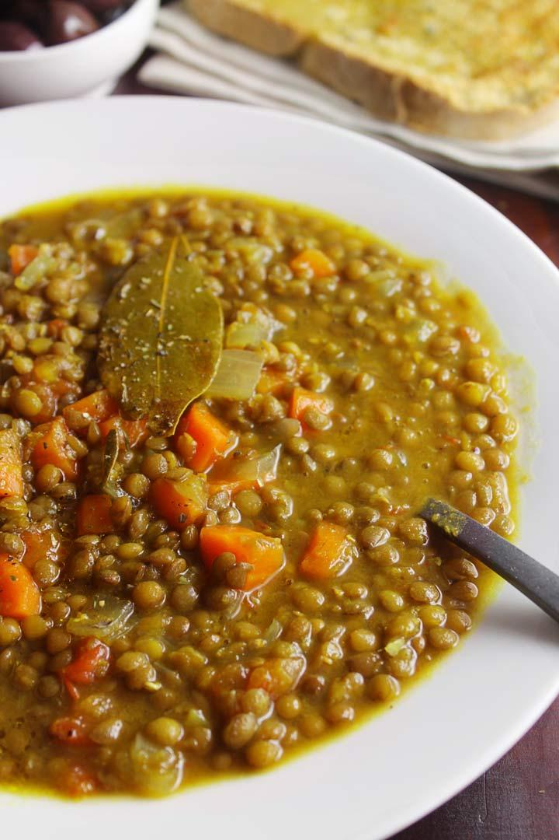

*Lentils double in size when cooked*

# Ingredients

* 2 cups Lentils
* 5 cups Water
* ½ Onion finely chopped
* 1 Carrot diced
* 1 Celery stalk diced
* 1 large Potato cubed (optional)
* 4-5 strips of Bacon OR 2-3 slices Ham
* ½ tsp Chili flakes
* 1 tspThyme
* 2 Bay leaves
* Salt + Pepper to taste

# Preparation

1. If you are using bacon, fry it in a large pan until crisp and remove. Saute the potatoes, carrots, and celery in the bacon fat until half cooked, adding in the onions about halfway through the process. If you are using ham, saute them in your choice of oil/ butter etc.
2. Clean the lentils and put them in a pot. Add the water, bay leaves, thyme and chili flakes and bring to a boil on high heat.
3. Reduce the heat to medium low and allow to simmer for ~15 mins.
4. Cut strips of cooked bacon or the ham slices into small pieces
5. Then add the remaining vegetables and bacon/ham, bring back to a boil and simmer for about 20 minutes until the lentils are soft. Salt and pepper to taste.